**SPH3U 9.1 Interference of Waves**

1. **Wave interference**

|  |  |
| --- | --- |
| Interference: |  |

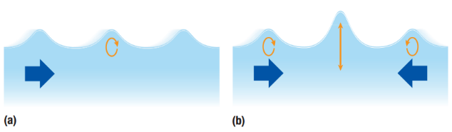

|  |  |
| --- | --- |
| Principle of superposition: |  |
| Constructive interference: |  |



|  |  |
| --- | --- |
| Destructive interference: |  |

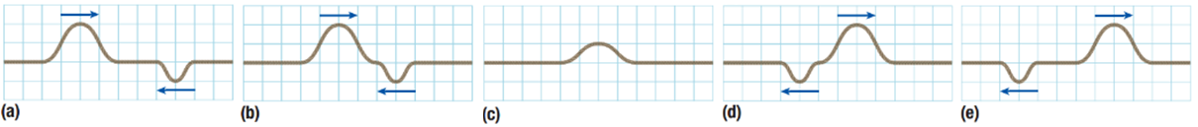

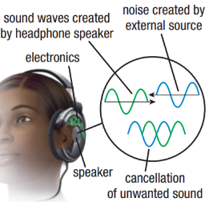

|  |  |
| --- | --- |
| Noise-cancelling headphones: |  |
| benefit |  |

These two waveforms are about to interfere with each other. Draw the resultant waveform.

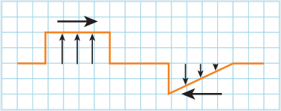

**Homework:** page 419: #1-2